ECB bus history
(https://www.retrobrewcomputers.org/doku.php?id=boards:ecb:start)
Below is the image of the latest definition of ECB bus as used by RetroBrew Computers group. It also describes issue with /RESET, /RESOUT pins definition and how it was solved. This design uses the 3-pin jumper header so that the proper configuration can be selected.

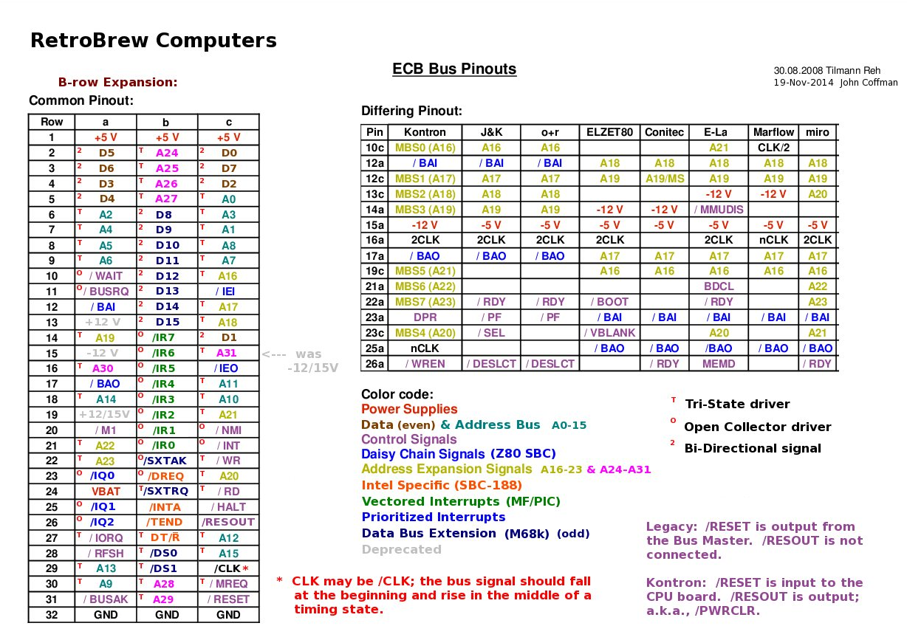
The German firm Kontron defined what is believed to be the earliest bus using the 96-pin DIN 41612 EuroCard connectors. The bus for their Z80 offering used only the A-row and C-row pins; the B-row was left entirely unused to allow for the use of 64-pin connectors in the 96-pin format.
The earliest known RetroBrew bus definition added B-row pin definitions in anticipation of expansion of the Z80 bus to other processors, notably Intel. To this day, the ECB SBC v2 (Z80) does not use the B-row pins.
One error occurred in defining the first RetroBrew bus: confusion between signals RESET (C-31) and RESOUT (C-26). The error resulted in a bad guess at what Kontron's intentions were with these two signals. SBC v1 (Z80) used RESET as an output from the CPU board to peripheral boards, and did not use the RESOUT signal at all. Peripheral boards were designed with this assumption. When it was pointed out several years ago (I am unsure of the date) that Kontron's intention was for RESET to be an input to the CPU board only, and that the CPU board would then put out a signal, RESOUT, to all of the peripheral boards in the system.
The resolution to the above mistake is that all the newer CPU and Peripheral boards have a reset selection jumper to select which RetroBrew reset convention is to be used. Look for a 3-pin jumper header: shorting pins 1-2 indicates the older, erroneous, reset convention for use with older boards; shorting pins 2-3 indicates the use of the Kontron convention. The Kontron convention is required if RESET is to be input from any of the ECB backplanes, and only newer board may be used in such a system. Old CPU boards have a 2-pin Reset (in) connection as well as a Reset switch right on the CPU card.

Generate baud rate for 8251

From chat gpt question:
How to use 8253 as baud rate generator

Response:
The 8253 Programmable Interval Timer (PIT) can be used as a baud rate generator for serial communication by generating clock pulses at the required frequency. This is done by programming one of its three counters to divide an input clock signal down to the desired baud rate.

Steps to Use 8253 as a Baud Rate Generator
- Select the Counter:
The 8253 has three counters (Counter 0, Counter 1, Counter 2). You need to choose one for generating the baud rate.
- Provide the Clock Input:
The 8253 typically receives a clock input (e.g., 1.8432 MHz or some other standard clock frequency). Ensure the clock is stable and properly connected.
- Calculate the Divider Value:
The baud rate is generated by dividing the input clock using a counter. The formula is:
Input Frequency RateDivider=Baud RateClock Input Frequency​
For example, if the input clock is 1.8432 MHz and you need a baud rate of 9600, the divider value is:
1843200÷9600=192
- Program the 8253:
  - Load the appropriate mode (typically Mode 2 – Rate Generator or Mode 3 – Square Wave).
  - Load the divider value into the selected counter.
  - Start the timer and route its output to the serial communication hardware (like 8251 USART or UART).
- Connect Output to Serial Device:
The output of the 8253 counter is connected to the baud rate clock input of a serial communication device like the 8251 USART or a UART module.

Example: Setting Baud Rate for 9600 using 1.8432 MHz Clock
- Use Counter 0 of 8253.
- Program it in Mode 2 (Rate Generator).
- Load 192 as the divider value.

Programming Steps (for an x86-based system)
assembly
CopyEdit
MOV AL, 34H ; Control Word: Counter 0, Mode 2, LSB/MSB
OUT 43H, AL ; Send control word to 8253
MOV AL, 192 ; Load LSB (Least Significant Byte)
OUT 40H, AL ; Send LSB to Counter 0
MOV AL, 0 ; Load MSB (Most Significant Byte)
OUT 40H, AL ; Send MSB to Counter 0
- 43H → Control port of 8253
- 40H → Counter 0 data port

Modes Used in 8253 for Baud Rate
- Mode 2 (Rate Generator) → Outputs a frequency suitable for baud generation.
- Mode 3 (Square Wave Generator) → Outputs a symmetrical square wave (useful in some applications).

Final Connection
The OUT0 pin of 8253 (if using Counter 0) is connected to the clock input of 8251 USART or UART for serial communication.

Summary
- Use Mode 2 (Rate Generator)
- Compute the divider value using the formula
- Program the control word and counter value
- Connect output to the serial device clock input.
This setup allows the 8253 to act as a baud rate generator for serial communication.

Baud rate devider
As crystal frequency is 18.432 Mhz and it is outputted from I8224, we can use that frequency to generate baud rate clock signal for I8251. Below is the solution.

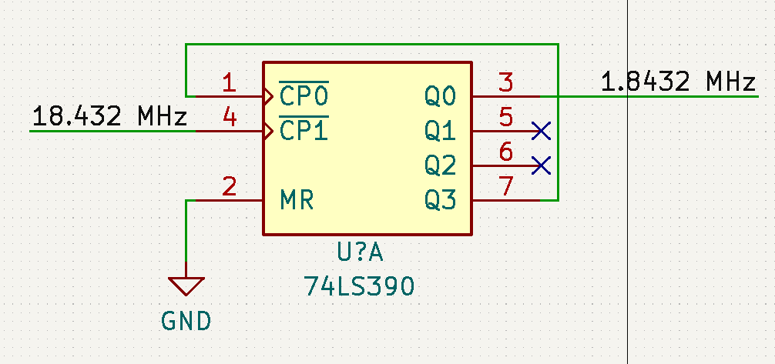
74LS390 is contains 2 decade counters where /CP0 → Q0 is divider by 2 and /CP1 → Q1, Q2, Q3 is divider by 5. We send 18.432 MHz clock signal from I8224 to /CP1, it is divided by 5 and then fed it to /CP0 where it is divided by 2. This arrangement will generate square signal with exact 50% duty cycle. Output signal from Q0 is then fed to I8252 timer where the proper baud rate can be generated.

Shadow FLASH select logic
In the picture below you can see shadow FLASH select logic schematics.

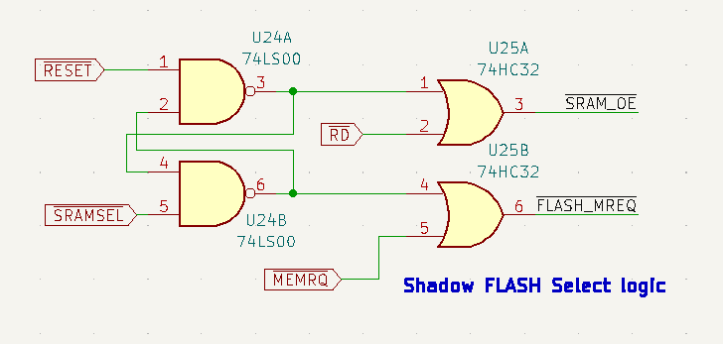
After /RESET (at this point /SRAMSELECT signal from IO decoder id HIGH) /SRAM_SEL is HIGH and /FLASH_SEL is LOW. Now /SRAM_OE is HIGH (DATA from RAM are in high impedance, though writing is not prohibited) so /RD signal has no effect on /SRAM_OE and only change of /MEMRQ will impact /FLASH_MREQ signal which means that only FLASH memory can be accessed either for reading or for writing. So it is also possible to flash the memory from a programmer on ECB bus.
Simulation has also been done in verilog (via iVerilog) and can be seen below.

/*
Test bench
*/

`timescale 10ns/10ns

module shadow_flash_select_logic_tb();

reg MEMRQ, RESET, SRAMSEL, RD;
wire SRAM_SEL, FLASH_SEL, SRAM_OE, FLASH_MEMRQ;

initial begin
$dumpfile ("shadow_flash_select_logic.vcd");
$dumpvars;
end

initial begin
RESET = 1;
#10
RESET = 0;
#5
RESET = 1;
end

initial begin
SRAMSEL = 1;
RD = 1;
MEMRQ = 1;
end

initial begin
#50;
RD = 0;
#50;
RD = 1;
#50;
MEMRQ = 0;
#50;
MEMRQ = 1;
#50
SRAMSEL = 0;
#50
RD = 0;
#50
RD = 1;
#50
MEMRQ = 0;
#50
MEMRQ = 1;
end

initial begin
#500;
$finish;
end

// The Netlist
nand(SRAM_SEL, RESET, FLASH_SEL);
nand(FLASH_SEL, SRAMSEL, SRAM_SEL);
or(SRAM_OE, SRAM_SEL, RD);
or(FLASH_MREQ, FLASH_SEL, MEMRQ);

endmodule

Simulation result in gtkwave is shown below.
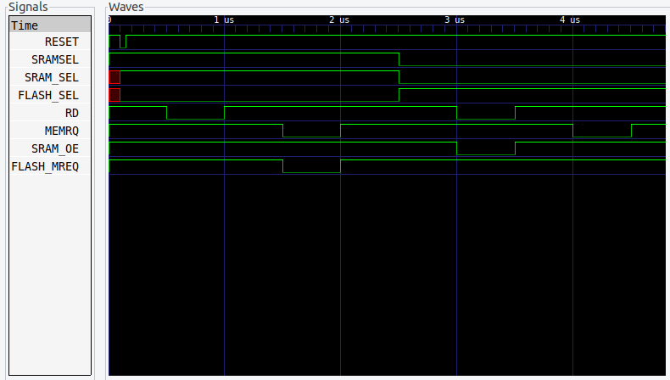

ECB bus data direction
As we have to also send and read data from ECB bus, we have to make sure that bus data buffers are properly directed if there is a bus request (BUSRQ) from the bus itself.
Signal DATA_DIR select the direction of data buffer. If DATA_DIR is log 0 data direction is from the board to ECB bus and if DATA_DIR is log 1data can flow from ECB bus to the board.
This is done by the circuit below. Basically upper part (/MEMRQ, /RD, /IOSEL which is low when internal periferals are selected) takes care of standard operations and upper part in involved when there is a request from the ECB bus. (/RD, /BUSAK)

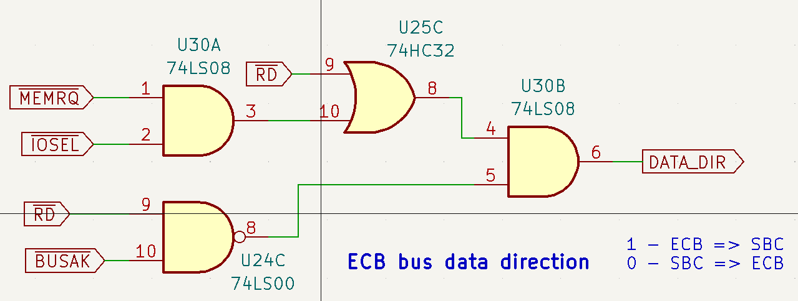
Below you can see simulation code and simulation result.

/*
Test bench
*/

`timescale 10ns/10ns

module shadow_flash_select_logic_tb();

reg MREQ, IOSEL, RD, BUSAK;
wire DATA_DIR, MREQ_IOSEL, RD_BUSAK, DATAEN;

initial begin
$dumpfile ("ecb_data_dir_logic.vcd");
$dumpvars;
end

initial begin
MREQ = 1;
IOSEL = 1;
RD = 1;
BUSAK = 1;
/* MREQ and RD */
#50
MREQ = 0;
#10
RD = 0;
#50
RD = 1;
#10
MREQ = 1;
/* IOSEL and RD */
#50
IOSEL = 0;
#10
RD = 0;
#50
RD = 1;
#10
IOSEL = 1;
/* BUSAK and RD */
#50
BUSAK = 0;
#50
BUSAK = 1;
#50
RD = 0;
#50
RD = 1;
end

initial begin
#500;
$finish;
end

// The Netlist
and(MREQ_IOSEL, MREQ, IOSEL);
nand(RD_BUSAK, RD, BUSAK);
or(RD_MREQ_IOSEL, MREQ_IOSEL, RD);
and(DATA_DIR, RD_MREQ_IOSEL, RD_BUSAK);

endmodule

And simulation result is below.
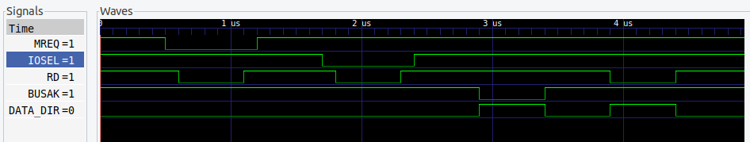

Peripherals address space
Internal peripherals are select by the following decoder.
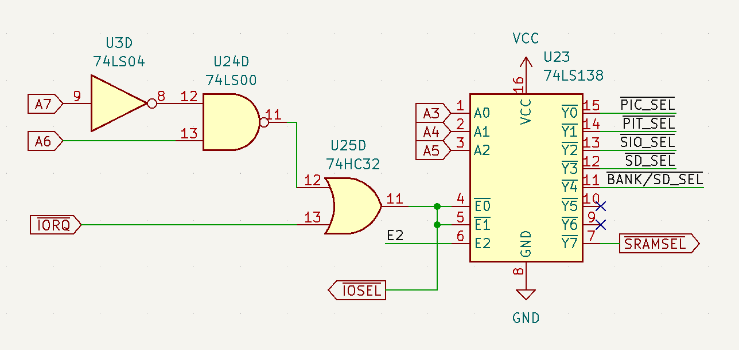
The address space with this circuit is 0x40 – 0x7f.
Where base addresses of peripherals are in the following table.

Peripheral | Address range
PIC 8259A | 0x40 – 047
PIT 8253 | 0x48 - 0x4F
SIO 8251 | 0x50 - 0x57
RAM bank/ SD card select register (/BANK/SD_SEL ) | 0x58 - 0x5F
RAM select signal (/SRAMSEL) | 0x78 - 0x7F

Below is verilog simulation result for a decoder.
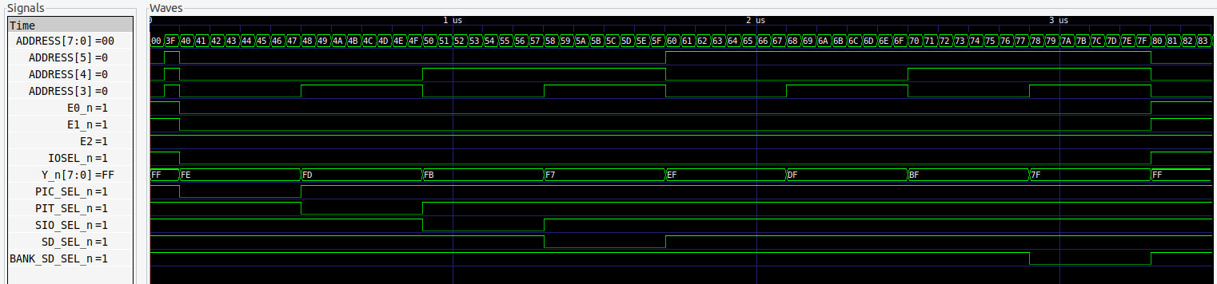
And the source code. I intentionally use primitives for simulation of 74LS138 to prevent some simulation glitches I got when I tried to use behavioral modeling. It is quite simplified as I’ve just wanted to verify address space for peripherals.
/*
Test bench
*/

`timescale 10ns/10ns

module SN74LS138(input [2:0] ADDR, input E0_n, E1_n, E2, output wire [7:0] Y_n);

not(E2_n, E2);
nor(ENBL, E2_n, E0_n, E1_n);
not(A_n, ADDR[0]);
not(B_n, ADDR[1]);
not(C_n, ADDR[2]);
not(A, A_n);
not(B, B_n);
not(C, C_n);
nand(Y_n[0], A_n, B_n, C_n, ENBL);
nand(Y_n[1], A, B_n, C_n, ENBL);
nand(Y_n[2], A_n, B, C_n, ENBL);
nand(Y_n[3], A, B, C_n, ENBL);
nand(Y_n[4], A_n, B_n, C, ENBL);
nand(Y_n[5], A, B_n, C, ENBL);
nand(Y_n[6], A_n, B, C, ENBL);
nand(Y_n[7], A, B, C, ENBL);

endmodule

module peripheral_decoder_tb();
reg [7:0] ADDRESS = 0;
reg A6, A7, IORQ_n;
wire [7:0] OUT;
wire A7_n, A7_A6, IOSEL_n, PIC_SEL_n, PIT_SEL_n, SIO_SEL_n, SD_SEL_n, BANK_SD_SEL_n;
integer I = 0;

initial begin
$dumpfile ("peripheral_decoder.vcd");
$dumpvars;
end

initial begin
IORQ_n = 0;
ADDRESS = 'h00;
for ( I = 'h3F ; I < 'hff; I = I + 1) begin
#5 ADDRESS = I;
end

end

initial begin
#350;
$finish;
end
assign PIC_SEL_n = OUT[0];
assign PIT_SEL_n = OUT[1];
assign SIO_SEL_n = OUT[2];
assign SD_SEL_n = OUT[3];
assign BANK_SD_SEL_n = OUT[7];
// The Netlist
SN74LS138 ls138(ADDRESS[5:3], IOSEL_n, IOSEL_n, 1'b1 , OUT);
not(A7_n, ADDRESS[7]);
nand(A7_A6, A7_n, ADDRESS[6]);
or(IOSEL_n, A7_A6, IORQ_n);
endmodule

